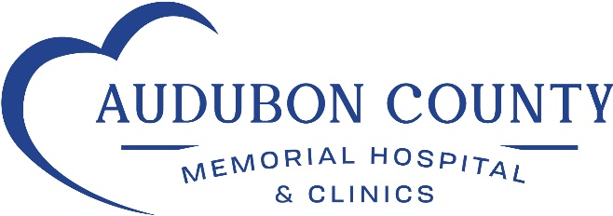

PRESS RELEASE

FOR IMMEDIATE RELEASE CONTACT: Susan Greving
Tuesday, October 25, 2022 PHONE: 712-563-5295
EMAIL: grevings@acmhhosp.org

ACMH Hosts Local Students Enrolled in Health Occupations Class

(Audubon, IA)- On October 18, 2022, Audubon County Memorial Hospital and Clinics hosted a group of local high school students that are currently enrolled Des Moines Area Community College’s Health Occupations Class.

These students are interested in exploring careers within the healthcare field, and ACMH is proud to partner with Amy Schultes from DMACC to give these students the opportunity to learn about different occupations.

The DMACC students were welcomed by the ACMH Administration team, Suzanne Cooner, CEO, Paul Topliff, COO, Haillie Bruch, HR Specialist and Melanie Larsen, Director for Quality, and Infection Prevention. The ACMH team gave the students an overview of the types of occupations within a rural healthcare facility, such as Audubon County Memorial Hospital and Clinics.

The students toured the hospital and clinics facilities including the newly retrofitted Emergency Department. They also had one-on-one time with different department heads such as Med Surg/ED, Lab, Radiology, and the family and specialty clinics. During these discussions, students learned about the education and certifications required for various jobs, advanced technologies available, job shadowing opportunities, and the specialty and services offered to patients at ACMH.

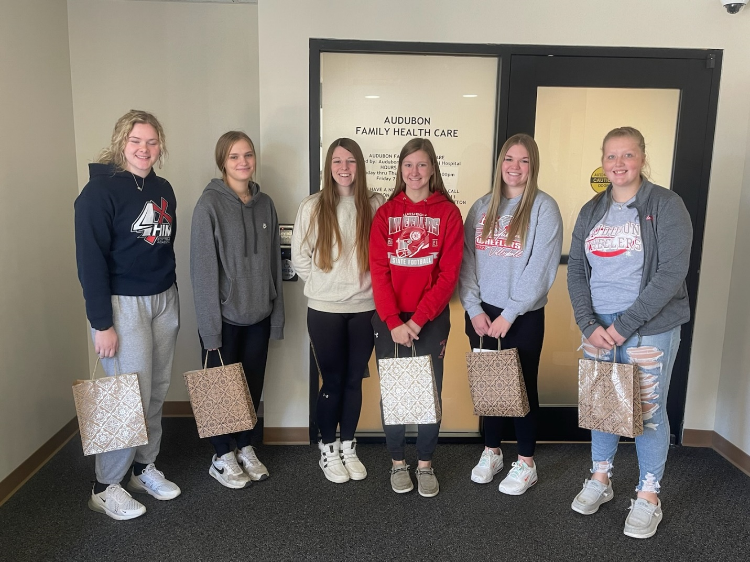

Local students were hosted by ACMH to explore job opportunities in healthcare.
(left to right): Lexi Gruhn, Alexandra Asmus, Kylee Hartl, Karly Hartl, Kacie Anthofer, Rylee Brittian

