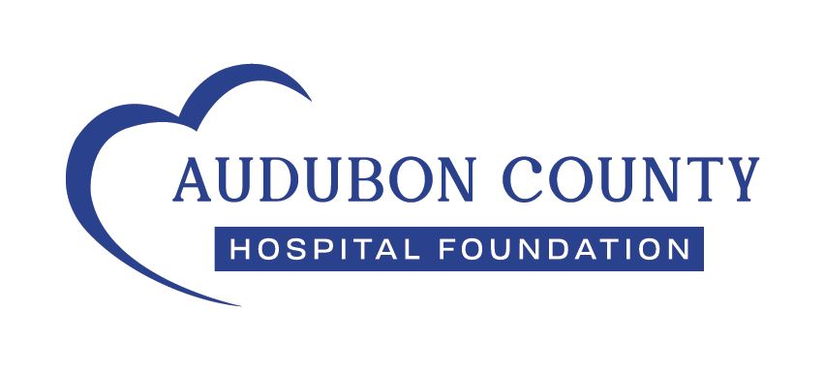
Bridget Jensen
507 Ann St.
Manning, IA 51455
January 21, 2024

Dear Bridget,

I am writing to thank you for your donation of funds to the Audubon County Hospital Foundation through the Audubon County Memorial Hospital employee scheduled payroll deduction program. Below is a list of gifts received during 2024 and the date each gift was received at the Foundation Office.

Bridget Jensen /ACHF Payroll Donations 2024
Gift Amount | Date Received | Gift Amount | Date Received
$0.00 | 1.5.24 | $2.00 | 7.5.24
$2.00 | 1.19.24 | $2.00 | 7.19.24
$2.00 | 2.2.24 | $2.00 | 8.2.24
$2.00 | 2.16.24 | $2.00 | 8.16.24
$2.00 | 3.1.24 | $2.00 | 8.30.24
$2.00 | 3.15.24 | $2.00 | 9.13.24
$2.00 | 3.29.24 | $2.00 | 9.27.24
$2.00 | 4.12.24 | $2.00 | 10.11.24
$2.00 | 4.26.24 | $2.00 | 10.25.24
$2.00 | 5.22.24 | $2.00 | 11.08.24
$2.00 | 5.24.24 | $2.00 | 11.22.24
$2.00 | 6.7.24 | $2.00 | 12.6.24
$2.00 | 6.21.24 | $2.00 | 12.20.24
2024 TOTAL: |  | $50.00

Total received through the scheduled payroll deduction program for 2024: $50.00

The Hospital Foundation could not support the Audubon County Memorial Hospital & Clinics with funds to promote positive changes in healthcare without your generous support.

Thank you again for your thoughtful gift!

Sincerely,
Susan Greving
Susan Greving
Foundation Director

Note: This letter shall serve as the receipt for your donations. Please retain it for your records.
No goods or services were received in consideration of this donation.
The tax identification number of the Foundation is 42-1422559.
(712) 563-5295 foundation@acmhhosp.org 515 Pacific Avenue Audubon, Iowa 50025

